Functional Programming – Tutorial 2

Question 1

Question 2

Question 3

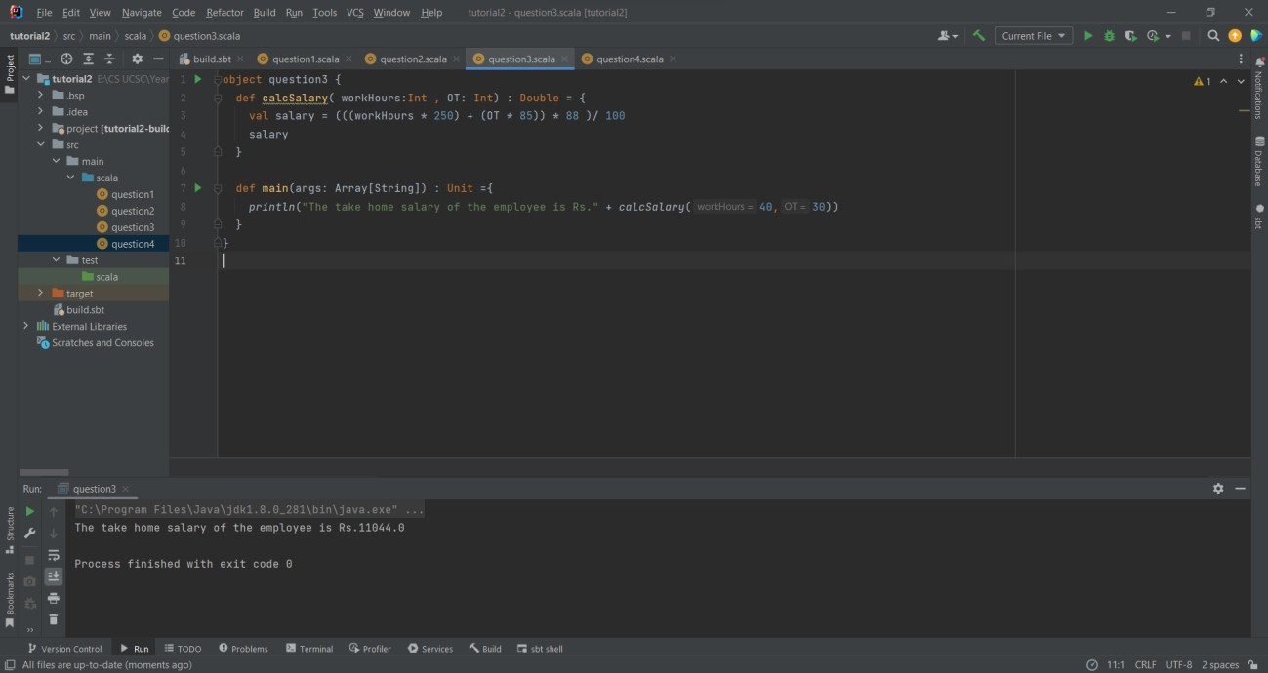

Question 4

